……………….. ……..

author's name and surname Date

**Term paper**

**Types of SSDs (List & Explanation)**

SSDs are all the fuss on the storage market, but there are actually different types of SSDs that perform at different tiers of speed.

In this article, we’re going to dive into everything you need to know about different types of SSDs, and help direct you toward the best SSD for your specific workloads.

Let’s dive into it!

**What Is An SSD?**

Before we get too deep into it, let’s go over what an SSD is, to begin with.

Laying down the basics now will make it easier to elaborate on what makes specific SSDs more or less special later on.

First, **SSD stands for Solid State Drive**. This is in comparison to a traditional **HDD, or Hard Disk Drive**.

HDDs use spinning disks to write and store data, and their speed is generally measured in RPM (Rotations Per Minute) in line with this.

SSDs don’t use RPM as a measurement at all, though, and the reason why ties back into that “**Solid State**” name. Basically, a component being “Solid State” means that it has no moving parts whatsoever.

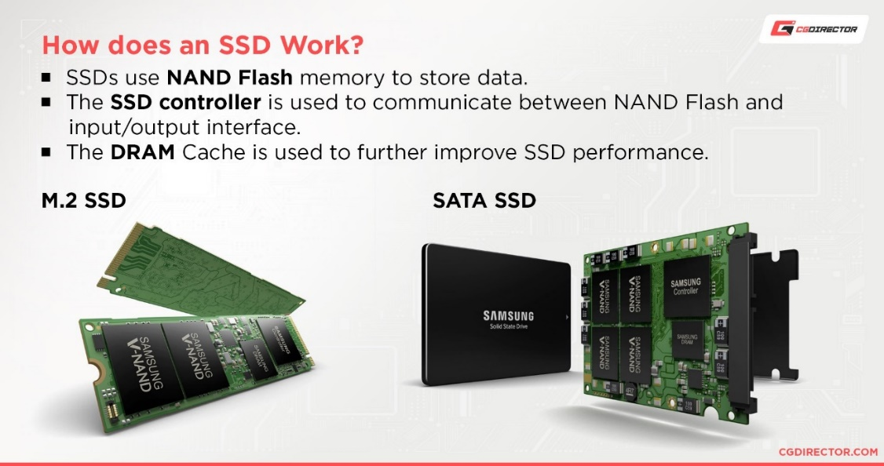

Pic1 How does an SSD work

**What is NAND?**

NAND is a non-volatile flash memory which can hold data even when it’s not connected to a power source. The ability to retain data when the power is turned off makes NAND a great option for internal, external and portable devices. USB drives, SSDs and SD cards all utilise flash technology, providing memory for devices such as your mobile phone or digital camera.

There are several types of NAND on the market. In simplest terms, what separates each type is the number of bits that can be stored per cell. The bits represent an electrical charge which can only hold one of two values, 0 or 1, on/off.

The key differences between the types of NAND are the cost, capacity, and endurance. Endurance is determined by the number of Programme-Erase (P/E) cycles a flash cell can undergo before it starts to wear out. A P/E cycle is the process of erasing and writing a cell and the more P/E cycles that the NAND technology can sustain the better the endurance of the device.

Common types of NAND flash storage are SLC, MLC, TLC and 3D NAND. This article discusses the different characteristics of each type of NAND.

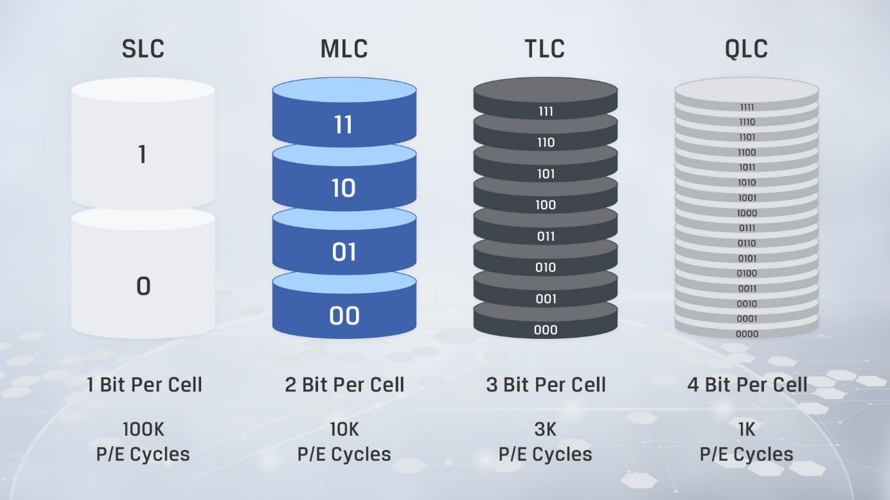

Pic2. Common types of NAND flash storage

**SLC NAND**

Single-level cell (SLC) NAND stores only 1 bit of information per cell. The cell stores either a 0 or 1 and as a result, the data can be written and retrieved faster. SLC provides the best performance and the highest endurance with **100,000 P/E cycles** so it will last longer than the other types of NAND. However, its low data density makes SLC the most expensive type of NAND and therefore not commonly used in consumer products. It is typically used for servers and other industrial applications that require speed and endurance.

**MLC NAND**

Multi-level cell (MLC) NAND stores multiple bits per cell, although the term MLC typically equates to 2 bits per cell. MLC has a higher data density than SLC so can therefore be produced in larger capacities. MLC has a good combination of price, performance, and endurance. However, MLC is more sensitive to data errors with **10,000 P/E cycles**and therefore has a lower endurance compared to SLC. MLC is usually found in consumer products where endurance is less important.

**TLC NAND**

Triple-level cell (TLC) NAND stores 3 bits per cell. By adding more bits per cell, this reduces the cost and increases the capacity. However, this has negative effects on performance and endurance, with only **3,000 P/E cycles**. Many consumer products will use TLC as it is the cheapest option.

**3D NAND**

In the last ten years, 3D NAND has been one of the biggest innovations in the flash market. Flash manufacturers developed 3D NAND to correct the problems they were facing with scaling down 2D NAND in order to achieve higher densities at a lower cost. In 2D NAND, the cells that store the data are placed horizontally, side by side. This means that the amount of space that the cells can be placed onto is limited and trying to make the cells smaller reduces their reliability.

Therefore, NAND manufacturers decided to stack the cells in a different dimension, which led to 3D NAND where the cells are stacked vertically. The higher memory density allows for higher storage capacities without the huge price increase. 3D NAND also provides better endurance and lower power consumption.

Overall, NAND is an extremely important memory technology as it provides fast erase and write times at a lower cost per bit. With the growth of the gaming industry, NAND technology looks to develop further in order to help satisfy consumers ever-increasing storage needs.

**SSDs use flash memory for storage.**

As it turns out, solid-state storage is a pretty significant improvement over hard drives, especially in terms of raw speed.

Even when limited to the HDD-focused SATA standard, SSDs consistently outperform standard HDDs across the board. And it makes sense if you think about it!

What’s going to be faster: a spinning platter being written to and read from with a mechanical arm? Or a surge of electricity?

That’s the basics of what an SSD is. Now, let’s break down your basic SSD types.

**Basic SSD Types**

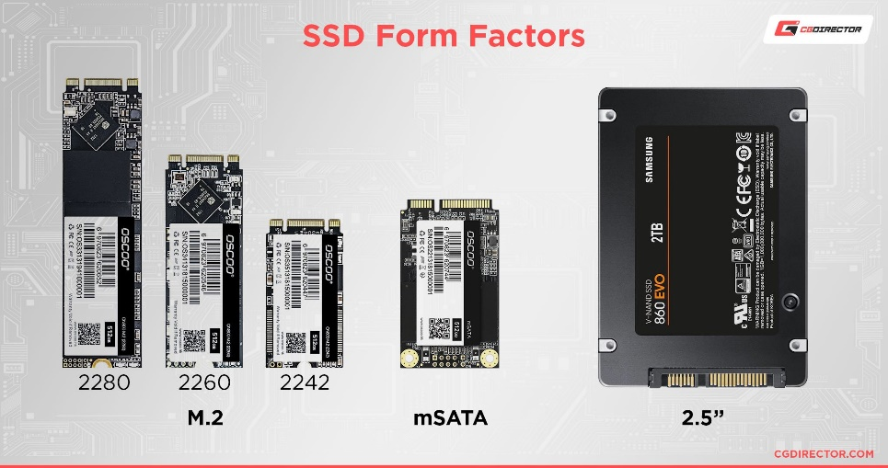

Pic.1 SSD Physical Formats

**2.5-Inch SATA SSD**

This is the most common SSD type and should be compatible with the widest range of PCs, even old ones. “2.5-Inch” refers to the form factor of the SSD enclosure, and there are actually 2.5-Inch HDDs, too.

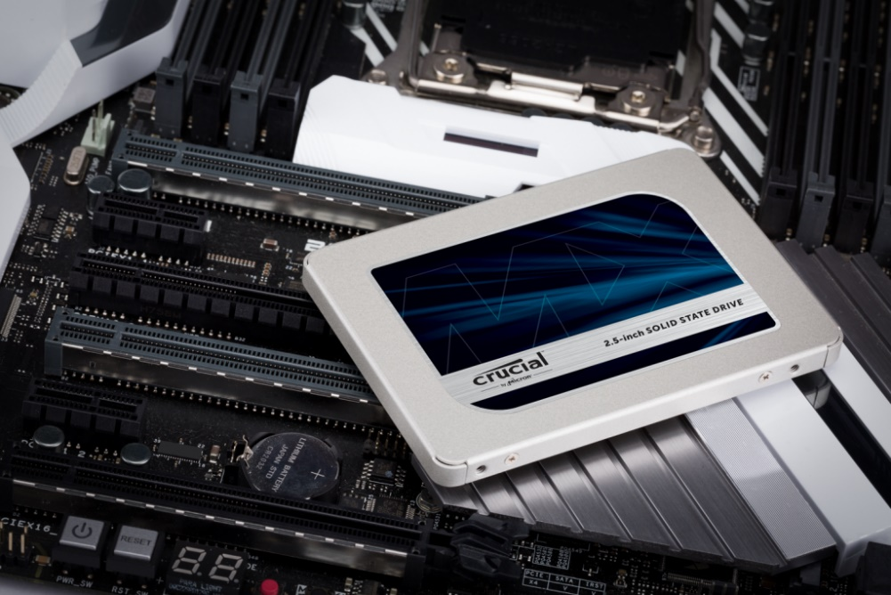

Pic. 3 - 2.5″ Solid State Drive placed on top of a motherboard – [Crucial](https://www.crucial.com/ssd/mx500/ct500mx500ssd1)

If you’ve ever noticed that a laptop hard drive looks a lot smaller than a desktop hard drive, that’s because laptop hard drives use 2.5-inch enclosures in order to fit into a smaller space.

In the case of hard drives, this can actually be a bit of a detriment, because it makes getting a full-speed 7200 RPM HDD just a bit more expensive than it would be with a standard 3.5-inch enclosure.

2.5-inch SSDs use SATA bandwidth and connectors, just like HDDs. Because of this, they should be compatible with any PC or laptop that’s already using a hard drive.

This makes them an ideal no-fuss storage upgrade or expansion for most users, and the majority of benefits you’ll get from an SSD upgrade can be experienced within the speeds allowed by the SATA standard.

*More on that in the Tiers of SSD Performance section.*

2.5-inch drives were made with the goal of making drive storage smaller, but most 2.5-inch SSDs are actually smaller still.

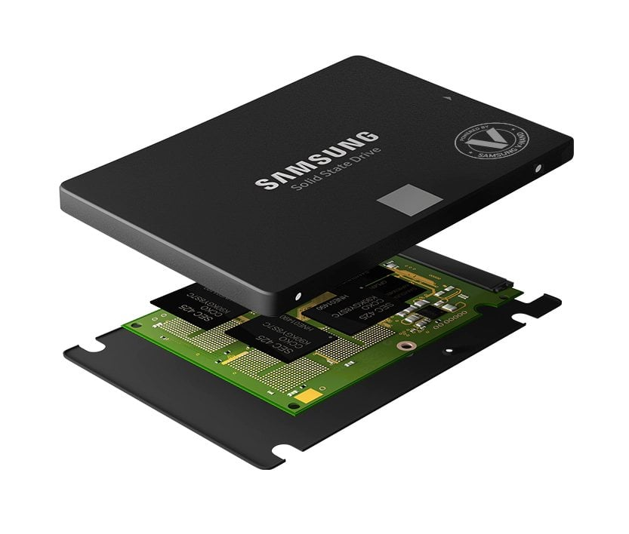

Pic. 3 No moving parts on the inside of this Samsung SSD, Source: [Samsung](https://www.samsung.com/)

The enclosure of any given 2.5-inch SSD is mostly empty (compared to 2.5-inch HDDs, which need all the space they can get), which means there’s actually still plenty of room for improvement.

**M.2 SATA SSD**

That’s where the M.2 form factor comes in!

**M.2 drives can come i the M.2 drive is 22 mill n a few different sizes, but the main standard is M.2 2280. The “22” means that imeters wide, whereas the “80” means that the M.2 drive is 80 millimeters long**.

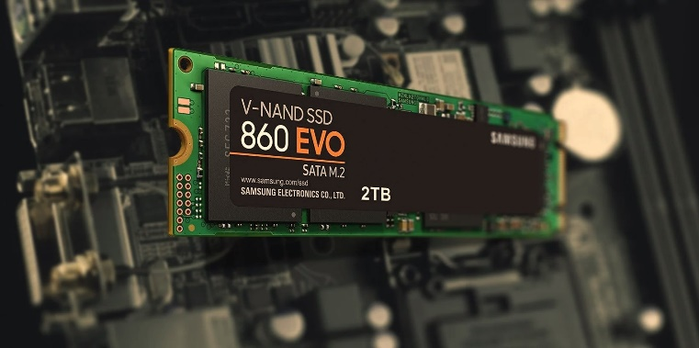

Pic. 4 Samsung **M.2 2280** SSD, Image-Credit: [Samsung](https://www.samsung.com/)

If you aren’t sure how to quantify this, just think of M.2 drives as extremely thin USB thumb drives- they’re about that length, usually. Like a stick of chewing gum.

There are other M.2 sizes, but they’re usually only relevant on a case-by-case basis: just check what form factor your particular laptop or motherboard supports before buying and you’ll be good.

While the M.2 form factor is a massive improvement over the 2.5-inch and 3.5-inch form factors required by hard drives, it doesn’t introduce an inherent boost in speed over SATA SSDs.

In fact, many M.2 drives still use SATA bandwidth, or can even be limited to SATA bandwidth by your motherboard despite being labeled as NVMe!

Be sure to double-check both your drive and PC’s specs before buying!

**M.2 NVMe SSD**

NVMe SSDs exclusively use the M.2 form factor discussed above, but with a catch: they are no longer using SATA bandwidth.

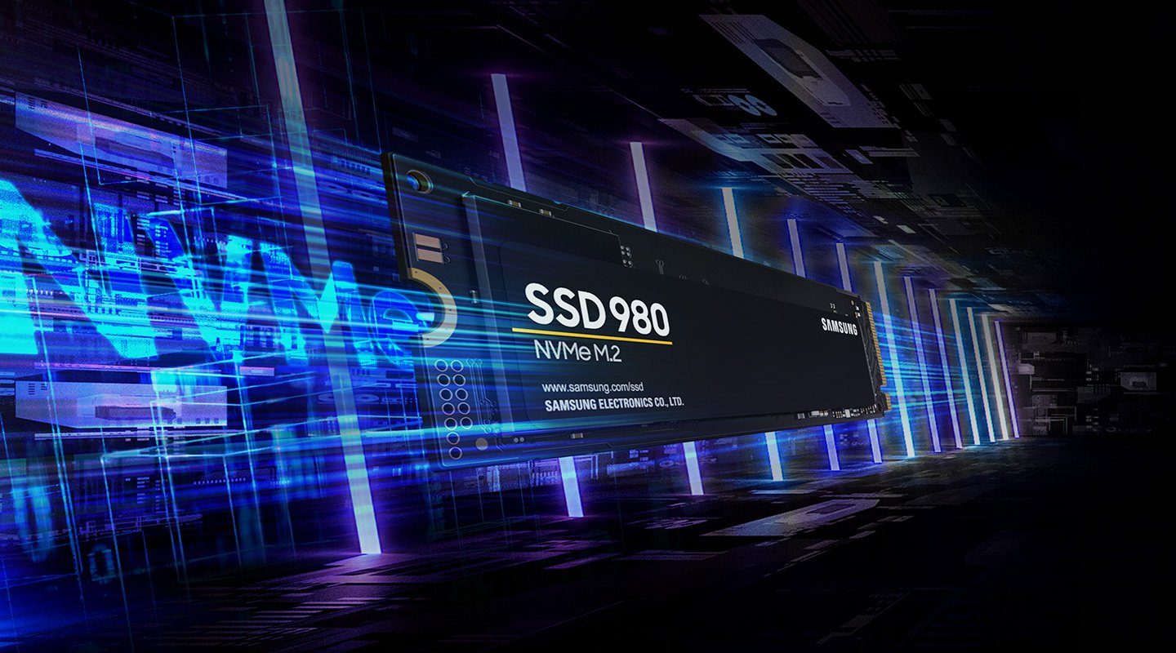

Pic6. M.2 NVMe SSD. Image-Credit: Samsung

Since SATA bandwidth is no longer a limiting factor, NVMe SSDs can achieve industry-leading storage performance while remaining extremely compact and straightforward to install.

**That “NVMe” stands for “Non-Volatile Memory Express”. The most important word to take note of there is “Express” because it reveals what bandwidth NVMe drives are actually using:** your [PCI Express bandwidth](https://www.cgdirector.com/guide-to-pcie-lanes/)**,** rather **than your SATA bandwidth**.

In most systems, PCI Express bandwidth is used by PCI Express cards, like your graphics card or even a sound card.

This results in some pretty huge performance improvements, which we’ll hop into in the Tiers of SSD Performance section.

**PCI Express SSD**

Last…and actually least, since their place in the market has largely been taken over by NVMe SSDs, are proper PCI Express SSDs.

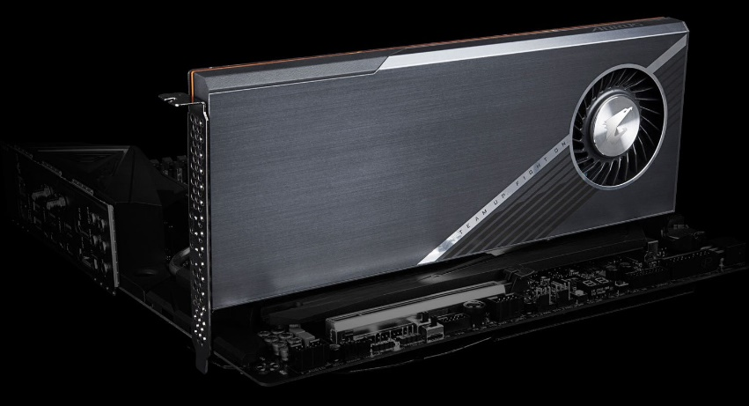

Pic. 5 Gigabyte Aorus PCIe SSD – Image-Credit: [Gigabyte](https://www.aorus.com/components/AORUS-Gen4-AIC-SSD-2TB/Key-Features)

These are SSDs that come in the form of PCI Express expansion cards and are ideal for motherboards that don’t support the M.2 form factor. Other reasons for PCIe Storage can be:

* You don’t want to use your chipset PCIe Lanes for your fast storage
* You want to RAID NVMe Drives to make them even faster or more reliable
* You don’t have room to mount your M.2 Drives because they are too tall
* All your [M.2 Slots](https://www.cgdirector.com/which-m2-slot/) are already used, but you require even more M.2 Drives

An interesting alternative, especially for that last option that we would recommend to most users in this scenario would be [using an M.2 PCIe Adapter](https://www.cgdirector.com/best-m-2-pcie-adapters-for-nvme-ssds/).

**Tiers of SSD Performance**

Now that we’ve gone over the basics of SSDs and SSD types, we can start biting into the *meat* of things.

SSDs are all about raw speed, and there’s actually quite a lot of variation in SSD speed from the entry-level to the high-end.

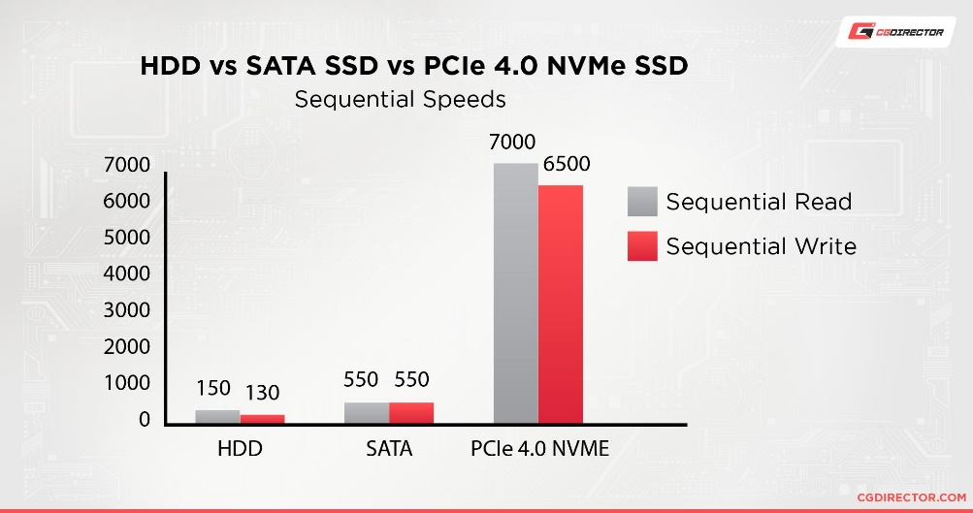

Pic. 7 Sequential Read/Write Performance Comparison of different Drive technologies. In MByte/s.

**Tier 1: SATA SSDs**

First up, **your standard SATA SSDs cap out at around ~550 MB/s in sequential read and write speeds**. This is pretty good, mind- that’s about half a gigabyte per second!

That is the best-case scenario for SATA SSDs, though- and not all SSDs are made equal.

For instance, [comparing Samsung’s EVO and QVO SSD lines](https://www.cgdirector.com/samsung-evo-vs-qvo-ssds/) reveal some pretty significant drops in performance for the QVO line since they’re reliant on a QLC architecture with small SLC buffer

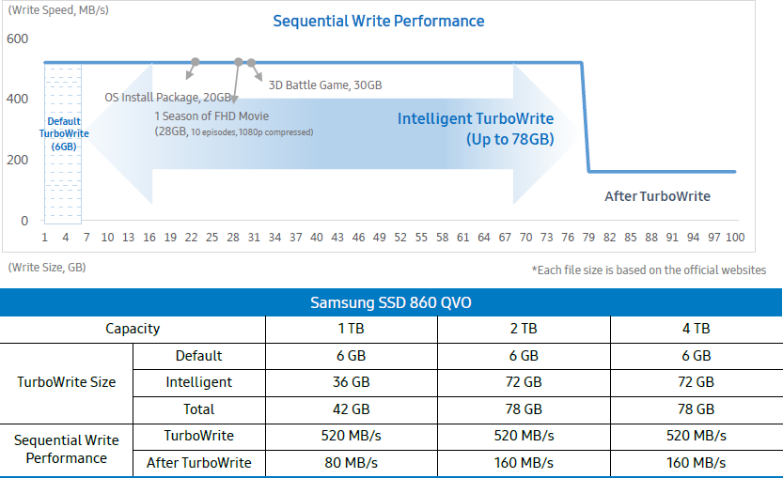

Pic. 9 QVO, Samsung’s most “affordable” offer limitations.

As a silver lining, this makes them a lot cheaper, but if you’re buying an SSD for speed alone, you may want to stick with the higher-end SATA SSD or NVMe options.

Despite there being much higher tiers of performance, SATA SSDs are still pretty great.

The majority of benefits that you will enjoy from an SSD upgrade will still be present with a SATA SSD.

Anything stored on your SATA SSD will load **much, much** faster than with an HDD.

This drastically cuts down on the time it takes to boot up your PC or load your games, and still makes SATA SSDs a compelling option for high-end users who want to add more storage without spending every possible dollar on NVMe.

**Tier 2: NVMe Gen3 SSDs**

Secondly, your NVMe Gen 3 SSDs! These cap out at around **3.5 GB/s in sequential read and write speeds, and *start*** **at around 1.5 GB/s in sequential read and write speeds**!

That’s right, we’re measuring storage speed in full Gigabytes per second now.

While NVMe Gen 3 does have a fairly massive boost in performance on paper, it may be tougher to notice the differences in regular usage.

There are a few different reasons for this, but it mainly boils down to most applications not really being built around that kind of storage speed even being *possible*, and the fact that other components, like your CPU, can start bottlenecking loading times around this point.

The main bottleneck being, that these speeds can only be reached for sequential file transfers. So writing or reading very large files sequentially. If you’re looking to launch an application, for example, chances are the files that need loading are randomly sized and not stored sequentially, making the process slower.

**The areas where** [**you’ll see the most benefit from an NVMe SSD:**](https://www.cgdirector.com/benefit-m2-nvme-ssd/) **large file transfers, video editing, gaming, and high-end rendering tasks.**

I especially want to emphasize the benefit to video editors for a moment, because combing through high-resolution footage in your editing software on an HDD is a *nightmare*.

NVMe SSDs improve that experience tremendously, allowing for smoother edits and high-quality real-time previews while still enjoying features like 4K footage.

**Tier 3: NVMe Gen4 SSDs**

NVMe Gen 4 SSDs are like NVMe Gen 3 SSDs, but, …more. **Specifically, these cap out at around 7 GB/s at the time of writing**!

There may yet be room for improvement with this and the upcoming NVMe Gen 5 (PCIe 5.0) standard, but we’re actually beginning to run into a different issue with storage this fast.

**Basically, NVMe SSDs are getting so fast that they are beginning to require dedicated heatsinks to stay cool enough** to keep operating at peak performance.

**Everything said about NVMe Gen 3 SSDs applies here…with a few caveats**. For one, if you had trouble noticing the difference before, this still isn’t going to change very much.

We generally don’t recommend NVMe Gen 4 SSDs for users who don’t actually need to make use of such ridiculously high-end speeds. This is [a product for high-end enthusiasts and professionals](https://www.cgdirector.com/most-expensive-pc-cases/), generally speaking.

**However, you may still be forced to buy an NVMe Gen 4 SSD despite not needing the highest-end speeds, because devices such as current generation consoles require them!**

The PlayStation 5 requires NVMe Gen 4 SSDs with a speed of at least 5.5 GB/s for internal storage upgrades, making NVMe Gen 4 surprisingly compelling for console gamers.

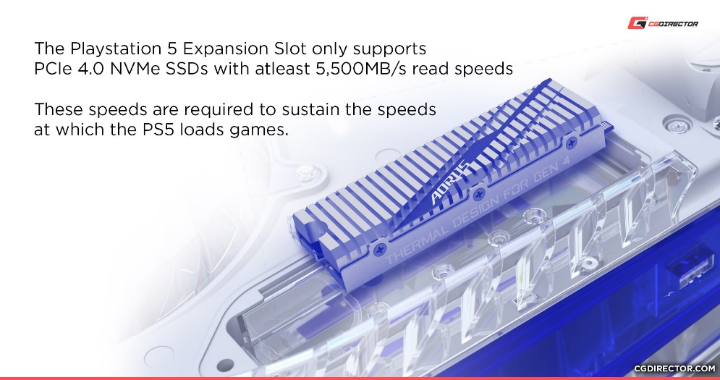

**As more games are built around speeds like these, we expect this tier of storage to become more popular among PC gamers, too.**

**Terabytes Written, or TBW**

TBW is the total amount of terabytes data that a Solid-State Drive (SSD) can write in its lifetime.

SSDs (Solid-State Drives) have been widely used in computer related territories for a while. However, the life of a SSD and the total SSD data amount that can be written is still an important topic to discuss.  Terabytes Written, or TBW, is the total amount of terabytes data that a SSD can write in its lifetime.

For example, a MLC 128GB SSD, which NAND has 3000 times P/E cycles, should be able to provide 128GB*3000 to equal 384TB data written theoretically. However, the NAND is composed of pages, the minimum unit for program, and blocks (composed of hundreds of pages), the minimum unit for erasing.

When the host writes files into a SSD, the total bytes written into the NAND usually are different from the data sent from the host. It is due to the size of each file being different from the NAND page, the alignment of data and the beginning of each page, and algorithms from SSD controller, such as data compression, which comprises the WAF, is usually not equal to 1. For example, if the system wants to write a 512-byte file into the SSD, the NAND needs to write the minimum size, the size of a page, such as 8 kbytes, and it makes the WAF= 8K/512=16. If the WAF is too big, it will make the TBW very small. However, every host and PC user might have different user frequency and habits, so the input data size combinations are quite different.

Therefore, JEDEC set up a standard, the JESD219 as SSD Endurance Workloads, for the workload of SSD. It includes Client and Enterprise workloads for different user scenarios.

The Enterprise workload has many small files compared to the Client workload, which makes the WAF of Enterprise much higher.

For example, the WAF for the Client workload for most of SSD is around 2 to 4 and the one for Enterprise varies at around 10.

For embedded applications, if the workload of the end user is different from these standards, a customized TBW calculation can be provided as a service.

The higher the TBW, the longer the SSD can be used.

**Bibliography**

Feng Chen, David A. Koufaty and Xiaodong Zhang (2009). "Understanding intrinsic characteristics and system implications of flash memory based solid state drives.". ACM Sigmetrics Performance Evaluation Review. pp. 181–192.

"SSD reliability in the real world: Google's experience". ZD Net. February 25, 2016.

Kerekes, Zsolt. [*"SSD Myths and Legends – 'write endurance'"*](http://www.storagesearch.com/ssdmyths-endurance.html). StorageSearch.com. ACSL.

Storage, Kevin Lee 2018-10-24T15:23:10Z (24 October 2018). [*"Adata's newest NVMe SSD promises 3,500MB/s read speeds for less"*](https://www.techradar.com/news/adatas-newest-nvme-ssd-promises-3500mbs-reads-for-less). TechRadar.